**PRITHWI SECONDARY BOARDING SCHOOL**

Basundhara Kathmandu contact:-01-5904816

**Final Term Examination**

**Grade: Nursery**

**Subject: math**

**Time :**

**Name :**

_________________________________________________________________________________

Q N.1 Fill in the missing numbers from 1 to 30. (9)

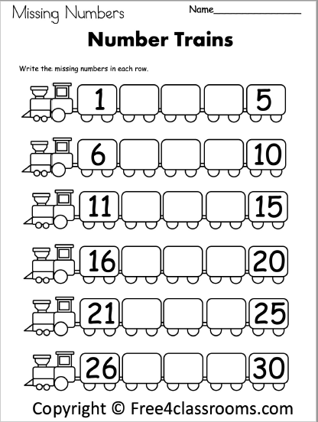

Q N.2 Circle the bigger object. (6)

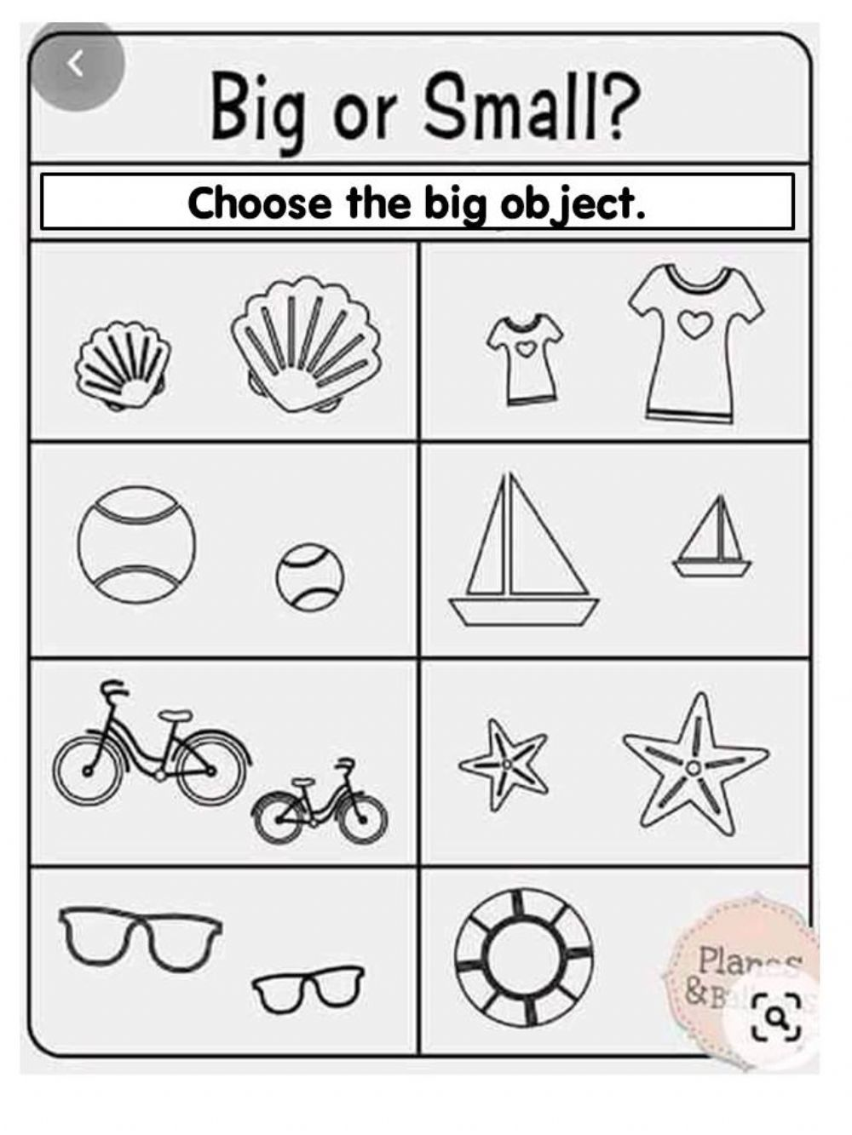

Q N.3 Count and colour the correct number. (6)

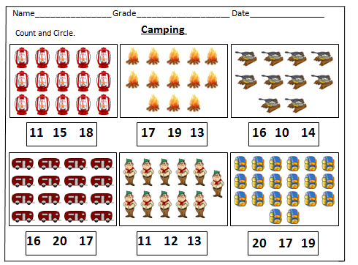

Q N.4 Circle the same numbers. (9)

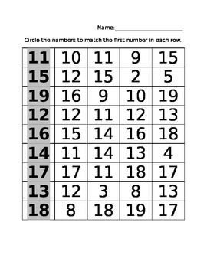

Q N 5 Colour the correct number of the object. (6)

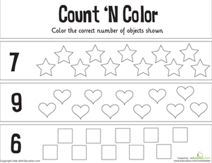

Q N.6 Write the numbers what comes after. (10)

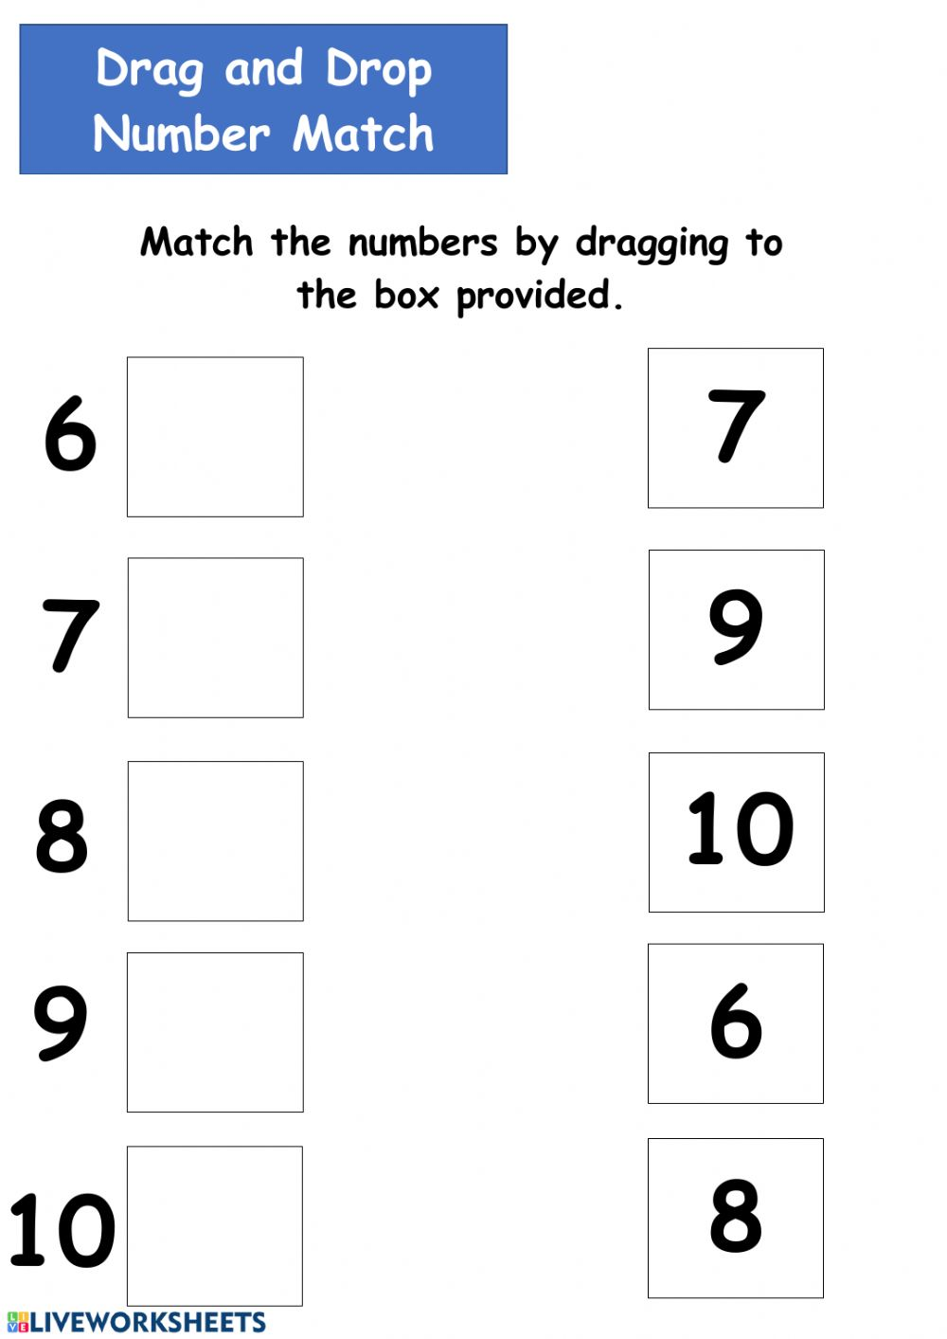

Q N 7. Join the dots and colour it. (4)

